Linear Regression – Comprehensive Notes

1.Introduction
Linear Regression is one of the most fundamental supervised learning algorithms used to model the relationship between a dependent variable (target) and one or more independent variables (features). The goal is to find a straight-line relationship that best explains how changes in input features affect the output.
In simple terms, linear regression tries to fit a line through data points such that the prediction error is minimized.

data.info() # printing the summary of the dataframe
data.isna().sum() # finding the count of missing values from different columns

2. Types of Linear Regression

2.1 Simple Linear Regression
- Involves one independent variable and one dependent variable.
- The relationship is represented using a straight line.

2.2 Multiple Linear Regression
- Uses multiple independent variables to predict a single dependent variable.
- Helps model more complex relationships where output depends on several inputs.

3. Mathematical Representation

3.1 Simple Linear Regression Equation
[ y = mx + c ]
Where:
y → predicted value (dependent variable)
x → input feature (independent variable)
m → slope (represents rate of change)
c → intercept (value of y when x = 0)

3.2 Multiple Linear Regression Equation
$$y=b_{0}+b_{1}x_{1}+b_{2}x_{2}+…+b_{n}x_{n}$$
Where: y= b₀ → intercept
b₁, b₂, …, bₙ → coefficients
x₁, x₂, …, xₙ → independent variables

4. Assumptions of Linear Regression
Linear regression works correctly only when its assumptions are reasonably satisfied:
- Linearity – Relationship between input and output should be linear.
- Independence – Observations must be independent of each other.
- Homoscedasticity – Variance of errors should be constant.
- Normality of Errors – Residuals should follow a normal distribution.
- No Multicollinearity – Independent variables should not be highly correlated.

Multicollinearity
Origin of the term:
The word multicollinearity is derived from two parts: multi, meaning multiple, and collinear, meaning linearly dependent.
Example:
If one variable can be expressed as a linear function of another, then a change in one variable will automatically cause a change in the other. This indicates a linear dependency between the two variables.

Definition
The goal of linear regression is to predict the value of a dependent variable using a set of independent variables. For this to work effectively, the independent variables should truly be independent of one another.
When one independent variable can be explained using another independent variable, the model includes redundant information. This undermines the purpose of regression, as multiple predictors are essentially conveying the same signal.
Multicollinearity refers to this situation—when two or more independent variables in a regression model are highly correlated with each other.

Why Multicollinearity Is a Problem
- In linear regression, coefficients represent the change in the dependent variable when one predictor changes while all others are held constant. If predictors are correlated, this assumption breaks down because changing one variable also affects another.
- It introduces redundancy, where multiple variables attempt to explain the same variation in the data.
- High multicollinearity can lead to unstable and unreliable coefficient estimates, increasing the risk of overfitting.
- It may result in issues such as the dummy variable trap, especially when using categorical variables.

Detecting Multicollinearity
- Correlation Matrix and Heatmaps
These are used to examine correlations among independent variables. Correlation values greater than 0.9 or less than −0.9 typically indicate problematic multicollinearity.
- Variance Inflation Factor (VIF)
VIF measures how much the variance of a regression coefficient is inflated due to multicollinearity.
A VIF value greater than 10 generally signals severe correlation that requires attention.

Remedies for Multicollinearity
- Ignore it: If the correlation is weak or does not affect the business objective, it may be acceptable to leave it unchanged.
- Remove one of the correlated variables: This is commonly done to avoid the dummy variable trap.
- Combine correlated variables: For example, creating a composite score using age and years of experience.
- Apply Principal Component Analysis (PCA): Transform correlated variables into a smaller set of uncorrelated components.

Bias–Variance Trade-off
Variance measures how much a model’s predictions change when trained on different datasets. High variance indicates that the model is overly sensitive to fluctuations in the training data.
Bias, on the other hand, measures the error introduced by overly simplistic assumptions in the model. High bias means the model consistently misses the true relationship in the data.
The goal of any predictive model is to achieve low bias and low variance, but in practice, reducing one often increases the other.

Understanding the Trade-off
If a model uses very few predictors, especially with large coefficients, it may rely too heavily on those predictors. In such cases, a small change in one predictor can lead to a large change in the output. This indicates high bias, as the model is too simple and favors specific features.
One way to reduce bias is to increase model complexity by adding more predictors. However, this increases the model’s sensitivity to data fluctuations, thereby increasing variance.
Mathematically, the total error can be expressed as:
Total Error = Bias² + Variance + Irreducible Error
- Irreducible error represents noise inherent in the data that cannot be eliminated by any model.
As bias decreases, variance tends to increase, and vice versa. Finding the right balance between them is known as the bias–variance trade-off.

Reducing Bias and Variance
- Bias can be reduced by training on more data or using a more flexible model.
- Variance can be reduced using regularization techniques, which constrain the model’s complexity.

Regularization
Regression models are prone to overfitting, especially when they become too complex. Regularization addresses this by limiting the flexibility of the model, effectively restricting the size of the coefficients.
In linear regression, large coefficients are undesirable because small changes in input values can cause large changes in the predicted output. Regularization discourages this behavior by penalizing large weights.

Ordinary Least Squares (OLS)
In standard linear regression, the model parameters are estimated by minimizing the cost function using the Ordinary Least Squares method.
To control overfitting, a shrinkage penalty is added to this cost function. This leads to different types of regularized regression.

Types of Regularization
Lasso Regression (L1 Regularization)
Lasso regression adds a penalty equal to the sum of the absolute values of the coefficients.
- The strength of the penalty is controlled by the parameter λ (lambda).
- As λ increases, more coefficients are pushed toward zero.
- With sufficiently large λ, some coefficients become exactly zero.
This makes Lasso useful for feature selection in addition to regularization.

Ridge Regression (L2 Regularization)
Ridge regression adds a penalty equal to the sum of the squared values of the coefficients.
- Like Lasso, it uses λ to control the amount of shrinkage.
- Ridge shrinks coefficients toward zero but never sets them exactly to zero.
As a result, all predictors remain in the model, which can make interpretation harder but improves numerical stability.

Choosing the Value of λ
The tuning parameter λ determines the balance between bias and variance:
- Small λ → low bias, high variance
- Large λ → higher bias, lower variance
The optimal value of λ is selected using cross-validation, by choosing the value that minimizes validation error.

Difference Between Ridge and Lasso
- Ridge Regression
  - Shrinks coefficients but keeps all predictors
  - Good when all features contribute somewhat to the outcome
- Lasso Regression
  - Shrinks some coefficients to exactly zero
  - Performs automatic feature selection

5. Cost Function (Loss Function)
To evaluate how well the model fits the data, a cost function is used.

Mean Squared Error (MSE)
$$J\left(m,c\right)=\frac{1}{n}\sum_{i=1}^{n}{(}y_{i}-{\hat{y}}_{i})^{2}$$
Where:
yᵢ → actual value
ŷᵢ → predicted value
n → number of data points
Lower MSE indicates a better fitting model.

6. Gradient Descent
Gradient Descent is an optimization algorithm used to minimize the cost function.

Steps Involved:
- Initialize parameters (m, c) randomly
- Computing predictions
- Calculate error using cost function
- Update parameters using gradients
- Repeat until convergence

Update Equations
$$m=m-α\frac{∂J}{∂m}c=c-α\frac{∂J}{∂c}$$
Where α is the learning rate.

7. Learning Rate
- Determines the step size during parameter updates
- Too large → model may diverge
- Too small → slow convergence
Choosing an optimal learning rate is critical for efficient training.

8. Model Training Process
- Load and preprocess data
- Split data into training and testing sets
- Train the linear regression model
- Evaluate performance using metrics
- Tune parameters if necessary

9. Evaluation Metrics

9.1 Mean Absolute Error (MAE)

$$MAE=\frac{1}{n}∑∣y-\hat{y}∣$$

9.2 Mean Squared Error (MSE)

Penalizes large errors more heavily.

9.3 Root Mean Squared Error (RMSE)

$$RMSE=\sqrt{MSE}$$

9.4 R² Score
- Measures how well independent variables explain the variance
- Value ranges between 0 and 1
For example, R^2 statistic = 0.75, it says that our model fits 75 % of the total data set. Similarly, if it is 0, it means none of the data points is being explained and a value of 1 represents 100% data explanation.
RSS is the residual(error) term and TSS: is the Total sum of squares and given as
TSS is calculated when we consider the line passing through the mean value of y, to be the best fit line. Just like RSS, we calculate the error term when the best fit line is the line passing through the mean value of y and we get the value of TSS.

The closer the value of R2 is to 1 the better the model fits our data. If R2 comes below 0(which is a possibility) that means the model is so bad that it is performing even worse than the average best fit line.
R-squared is susceptible to model overfitting, and thus there is no guarantee that a model with a high R-squared value will generalise.
Hypothesis Testing
Hypothesis testing is closely linked to confidence intervals. It begins by defining a null hypothesis and an alternative hypothesis that contradicts it. Statistical evidence from the data is then used to determine whether the null hypothesis should be rejected or whether there is insufficient evidence to reject it.

10. Overfitting and Underfitting

Underfitting
- Model is too simple
- Fails to capture data patterns

Overfitting
- Model fits training data too closely
- Performs poorly on unseen data

11. Bias–Variance Tradeoff
- High Bias → underfitting
- High Variance → overfitting
A good model maintains a balance between bias and variance.

12. Advantages of Linear Regression
- Easy to understand and interpret
- Computationally efficient
- Works well for linearly related data

13. Limitations of Linear Regression
- Assumes linear relationship
- Sensitive to outliers
- Performs poorly with complex non-linear data

14. Applications of Linear Regression
- Price prediction
- Sales forecasting
- Risk assessment
- Trend analysis

15. Conclusion
Linear Regression serves as a foundational algorithm in machine learning. Despite its simplicity, it provides strong baseline performance and is widely used in real-world prediction problems. Understanding linear regression is essential before moving to advanced models.
Polynomial Regression
To understand polynomial regression, we first need to understand what a polynomial is. A polynomial is a mathematical expression made up of one or more terms, where each term consists of a constant multiplied by a variable raised to a non-negative integer power (for example, $a+bx+cx^{2}$). In simple terms, poly means “many,” so a polynomial is a combination of multiple terms involving the same variable.
A general polynomial equation can be written as:
$$y=a_{0}+a_{1}x+a_{2}x^{2}+⋯+a_{n}x^{n}$$
Polynomial regression is a regression technique used to model a non-linear relationship between an independent variable and a dependent variable by fitting a polynomial equation to the data.

Degree of a Polynomial
The degree of a polynomial is the highest power of the independent variable $x$.
- Degree = 1 →
$$y=a_{0}+a_{1}x$$
This is simple linear regression.
- Degree = 2 →
$$y=a_{0}+a_{1}x+a_{2}x^{2}$$
This represents a quadratic relationship.
- Higher degrees allow more complex curves but also increase the risk of overfitting.

When to Use Polynomial Regression
Polynomial regression is useful when:
- You need to perform regression, but
- The relationship between the independent variable $X$and dependent variable $Y$is not linear.
A linear relationship produces a straight-line pattern, which linear regression can model effectively. However, in many real-world cases, the data follows a curved pattern that cannot be captured by a straight line.
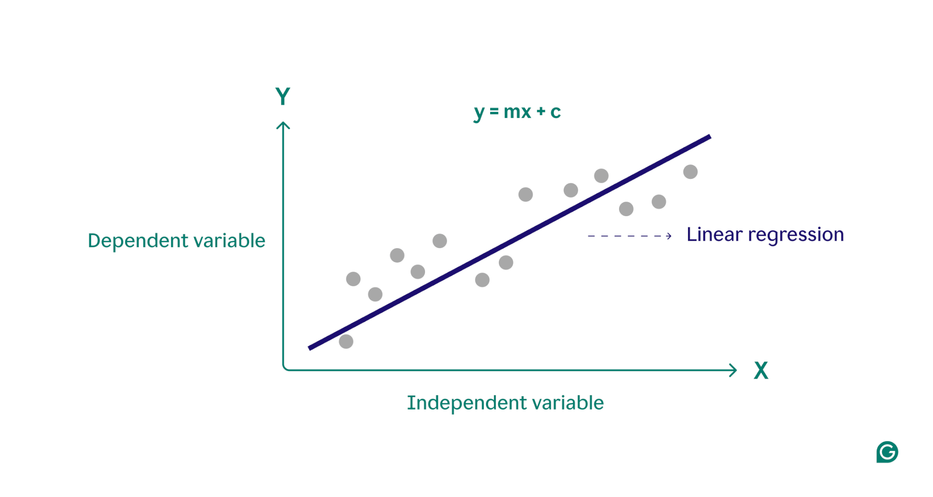
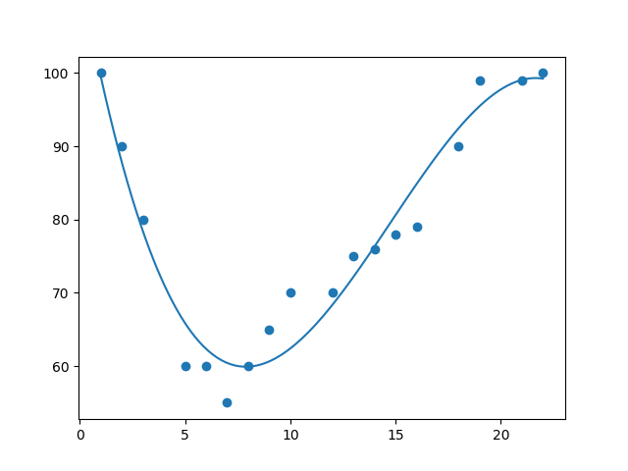
In such cases, polynomial regression allows the model to fit a curve that better represents the underlying relationship.

Mathematical Perspective
In linear regression, the model parameters are estimated to be using a design matrix with two coefficients (slope and intercept). Polynomial regression generalizes this idea by expanding the feature space to include higher powers of $x$.
For a polynomial of degree $m$, the model has $m+1$coefficients. If there are $n$data points, the resulting design matrix has:
- $n$rows (observations)
- $m+1$columns (polynomial terms)
This expanded representation allows the model to capture non-linear patterns while still using linear regression techniques under the hood.

